**PROJECT OBJECTIVES**

**Create IBM Watson IoT Platform and Device**

**Team Id : PNT2022TMID19409**

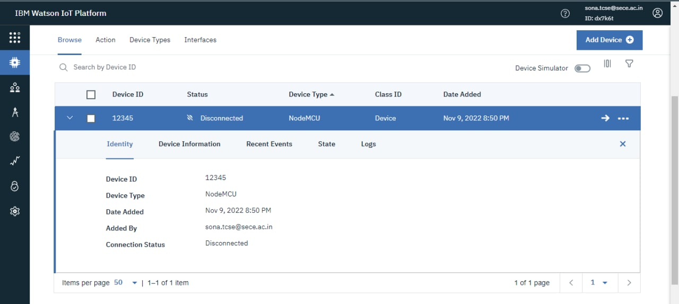

**Rithanya K**

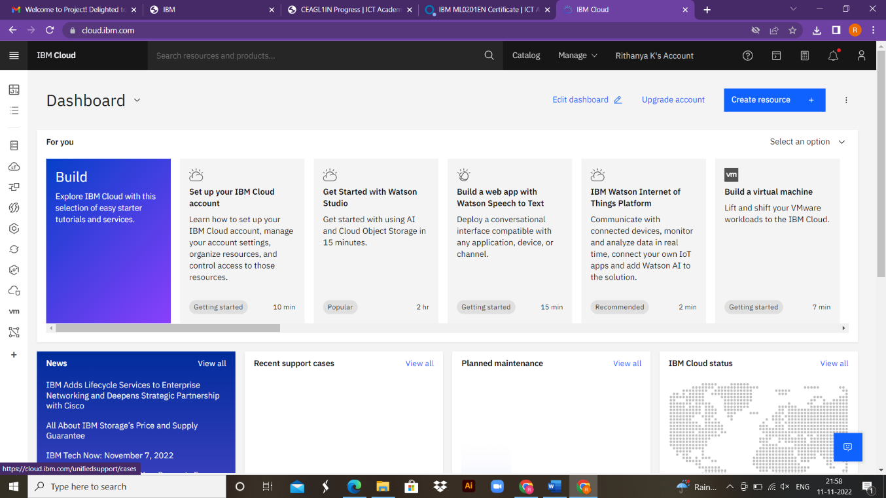

**Venkatesh Manikanda Prabhu**

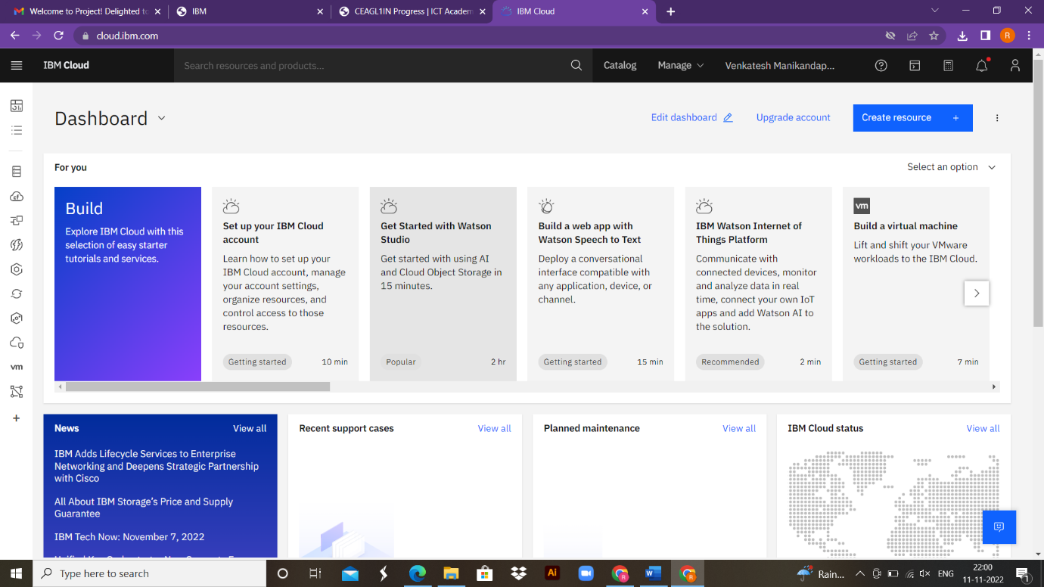

**Srimathi V**